**ABSTRACT**

An 8-module user login authentication project with 7 modules given and 8th module being the Unique Value Proposition.

The 7 modules include:

1. Onboard the user – username, password, email id
2. Setting up the answers to 5 security questions
3. Log in
4. OTP verification using email
5. Answering 3 questions which pop-up randomly, out of the 5 saved in step 2 – hints provided
6. Integration of the aforementioned modules
7. Database schema and integration

Customized value additions (8th module):

* OTP verification using phone number if email id does not exist
* Forgot Password
* OTP timer and 3 attempts
* Postgres on AWS
* Email notification after sign up

**SETUP**

**Python Installation**

For this project, we were asked to install the latest stable version of the Python 3.9 series. You can download the setup using the following link:

<https://www.python.org/downloads/>

After installation, you can check the installed version of python.

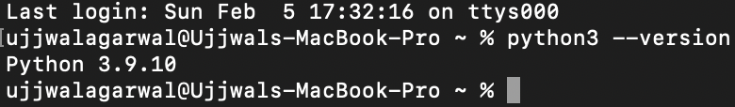

**PostgreSQL Installation**

For this project, we were supposed to install the version 15 of PostgreSQL with a client (preferably Pg-Admin).

You can download the setup and follow the installation instructions using the following link:

<https://www.postgresqltutorial.com/postgresql-getting-started/install-postgresql-macos/>

**Additionally, install an IDE of choice and push the code on Git as you go.**

**On-boarding the user and setting up the answers to security questions**

**Screenshot of On-Boarding page**

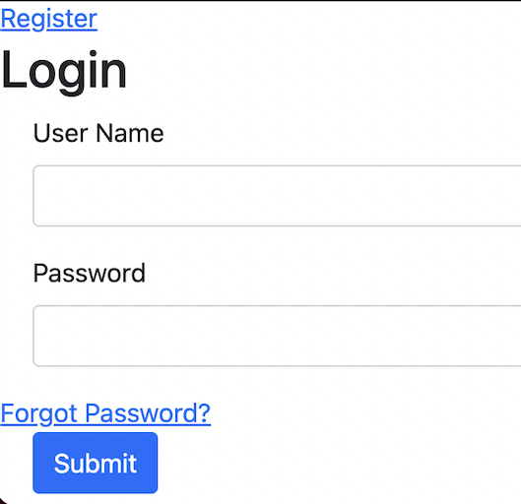

For your registration you need to click on **“Register”** and enter the required details**.**

**Screenshot of registration page**

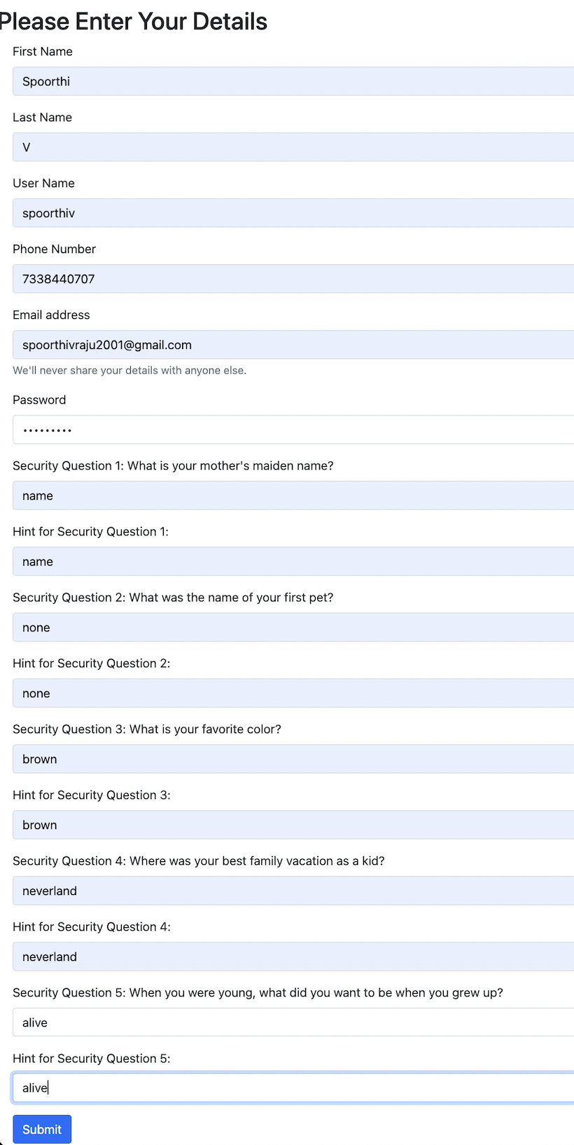

You need to fill the aforementioned details and security questions for completing the registration process.

After successful registration you will be again directed to the login page.

**Login**

**Screenshot of login page**

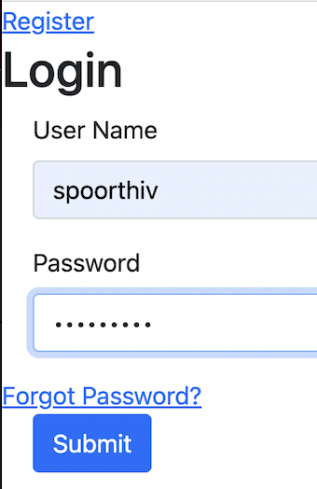

You can now login using your credentials.

After entering your login credentials, you will be directed to a page where your mail id will be verified.

**OTP verification**

**Screenshot of OTP sent on registered mail id**

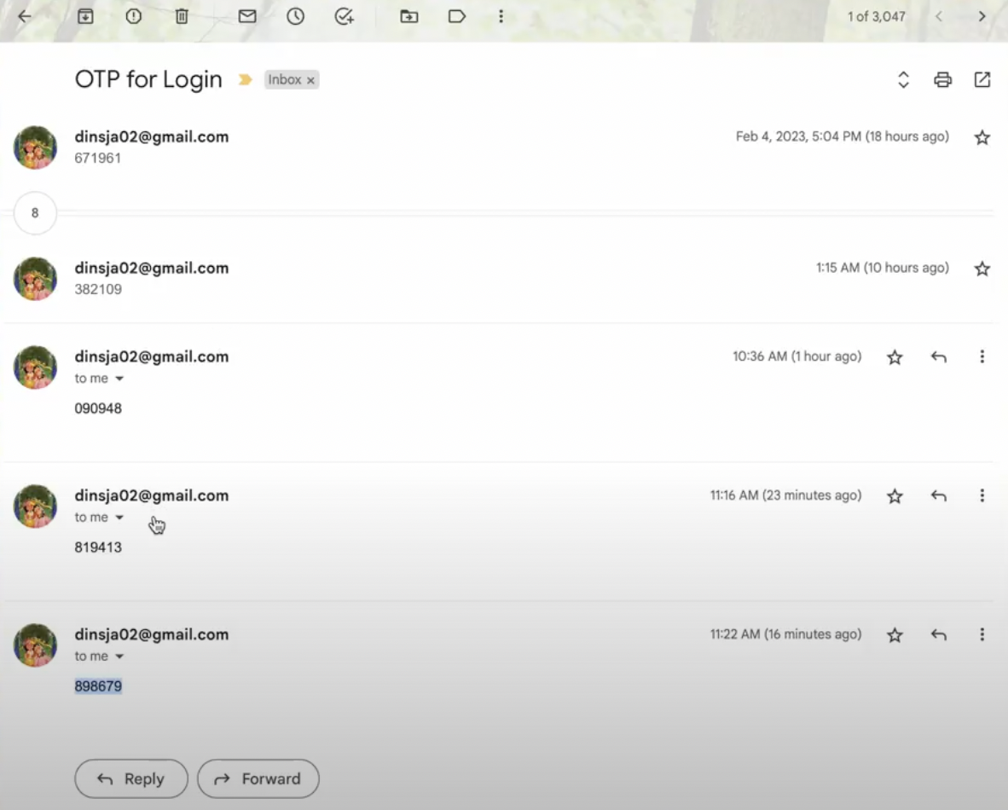

You need to enter the OTP as this is the part of authentication process.

**Screenshot of OTP page**

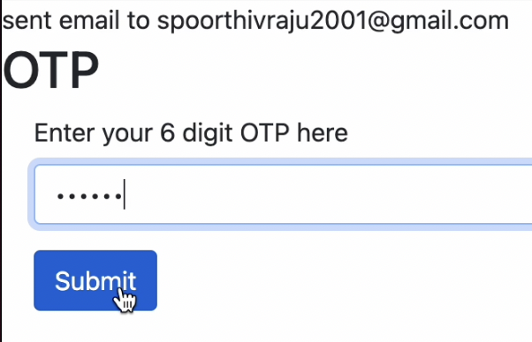

After entering your OTP here, it will be verified at the backend, and you will be directed to the security question page once the OTP matches.

**Authentication using Security Questions**

**Screenshot of security Q**

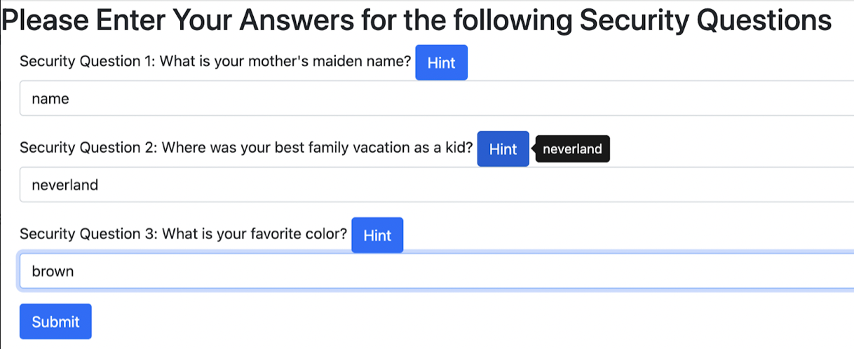

Here you need to answer questions as again this is the part of authentication process. For answering the questions, you can take help of hints as well.

**Screenshot of successful login**

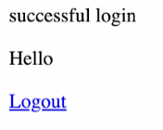

This shows that you have successfully logged in.

**Database Schema**

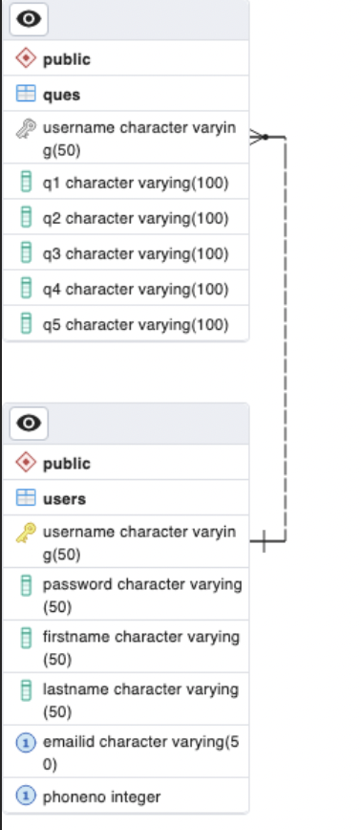

This is the database schema of tables which we have created from where all our data will be fetched and get stored.

**Forgot Password**

**Screenshots of Forgot Password page**

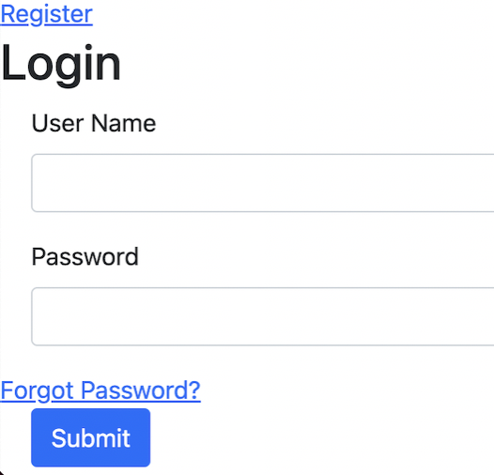

If you forgot your password, then you can click on **“Forgot Password”.**

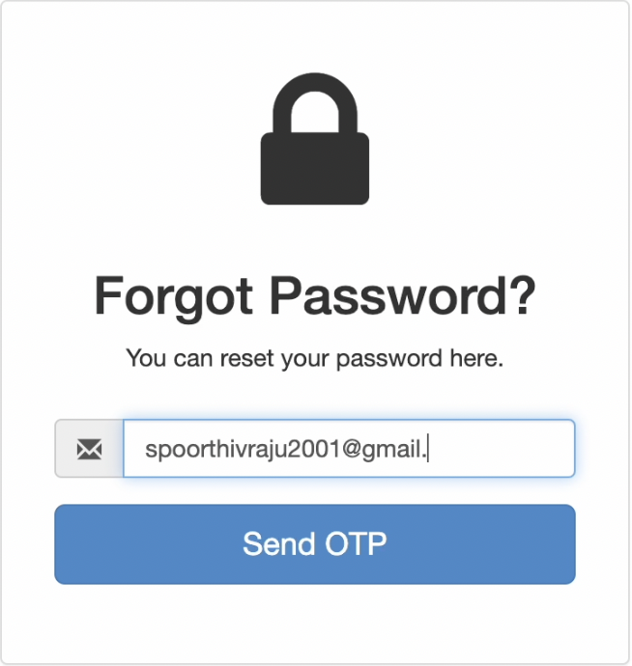

Here you need to enter your mail I’d where you need OTP for setting new password.

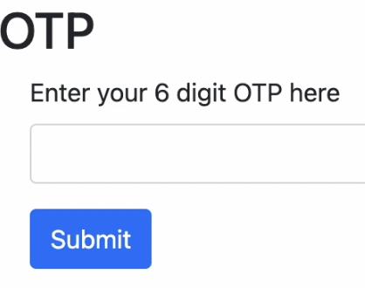

Here you must enter the OTP received on your registered mail I’d.

Here you need to set your new password. After confirming the password, you will be directed to the login page to enter your new credentials.

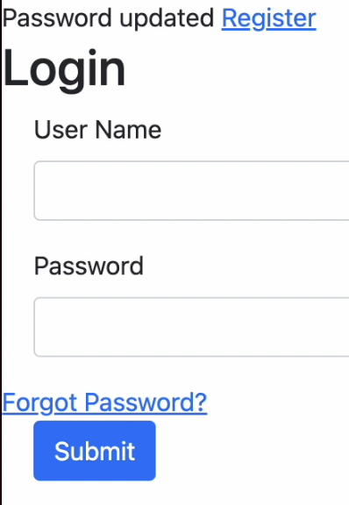

**OTP on Phone No.**

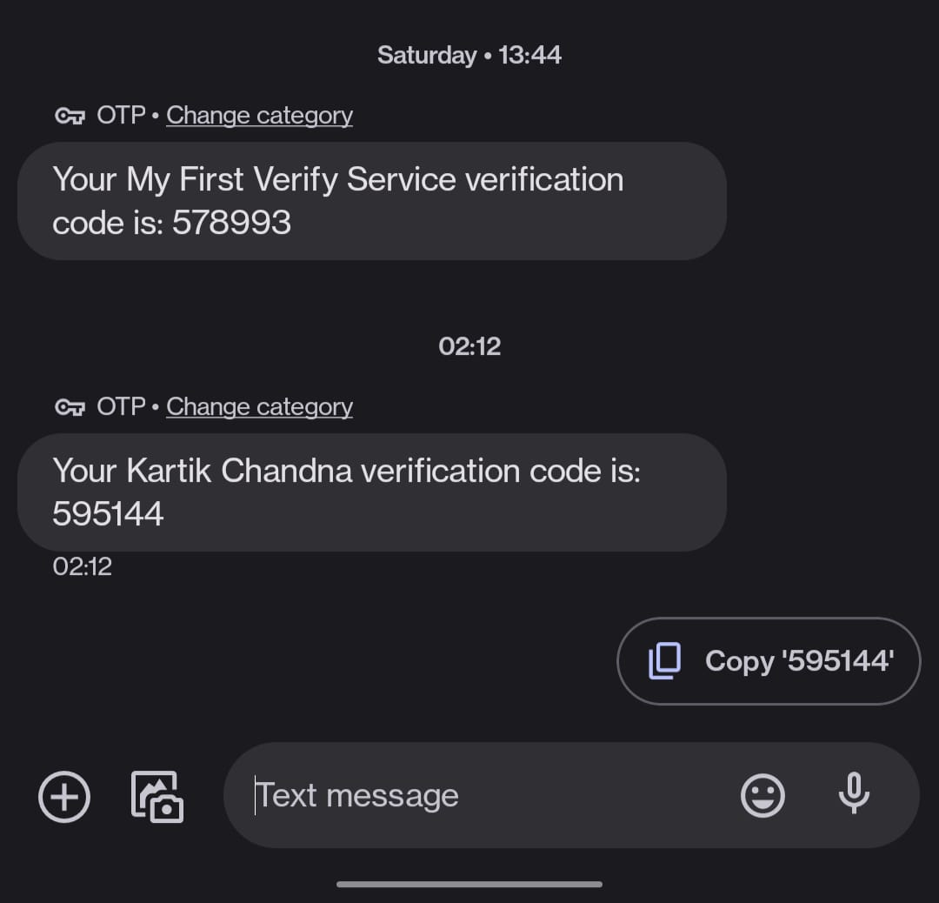

If a user doesn’t have an email id, then OTP will be sent to their mobile number for user authentication.